**Model Documentation: CNN Architecture**

This is the documentation for the Convolutional Neural Network (CNN) model designed for text classification tasks. This model architecture uses word embeddings and multiple convolutional layers followed by dense layers for classification.

**Model Overview:**

The model architecture consists of an embedding layer, multiple convolutional layers, and fully connected dense layers.

**Architecture Diagram:**

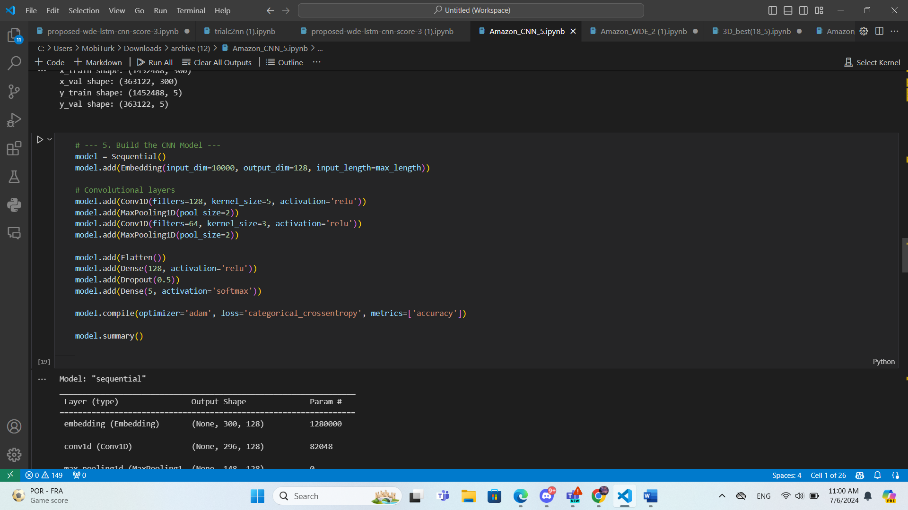

**Architecture Description:**

1. **Embedding Layer**:
   * **Input dimension**: 10000 (vocabulary size)
   * **Output dimension**: 128 (embedding vector size)
   * **Input length**: 300 (maximum sequence length)
   * Converts input text sequences into dense vector representations.
2. **Convolutional Layers**:
   * **Conv1D Layer 1**:
     + **Filters**: 128
     + **Kernel size**: 5
     + **Activation**: ReLU
   * **MaxPooling1D Layer 1**:
     + **Pool size**: 2
   * **Conv1D Layer 2**:
     + **Filters**: 64
     + **Kernel size**: 3
     + **Activation**: ReLU
   * **MaxPooling1D Layer 2**:
     + **Pool size**: 2
   * Extracts local features from the embedding output.
3. **Flatten Layer**:
   * Flattens the output from the convolutional layers to prepare it for the dense layers.
4. **Fully Connected Layers**:
   * **Dense Layer 1**:
     + **Units**: 128
     + **Activation**: ReLU
   * **Dropout Layer**:
     + **Dropout rate**: 0.5
   * **Dense Layer 2**:
     + **Units**: (5, or 3, or 2)
     + **Activation**: Softmax
   * Performs the final classification.

**Model Compilation**

* **Loss Function**: Categorical Crossentropy (Binary Crossentropy for score 2)
* **Optimizer**: Adam
* **Metrics**: Accuracy

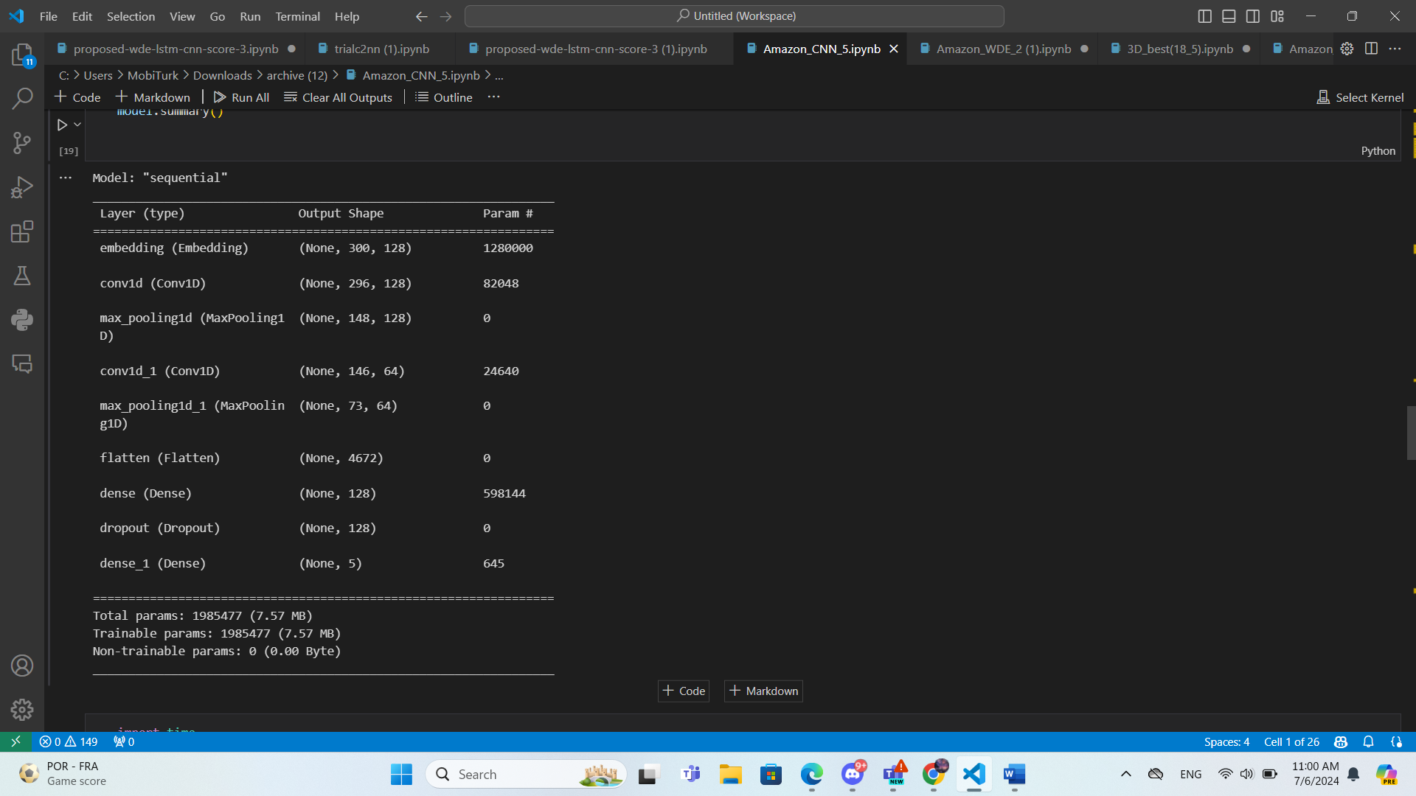**Model Summary:**